Batch File Utility – Report

Operating Systems Assignment (010-1) – Trimester 2, 2024/25

  - Student ID: 2211625
  - Course: BEng (Hons) Computer Science
  - Module Code: MOD003218
  - Module Title: Operating Systems
  - Module Leader: Dr Vanessa Ng
  - Submission Deadline: 11/4/25

Contents:

Introduction: 3
Bat File Code 4
Linux Code 6
Explanation of program logic: 7
Psudocode: 7
Flow Chart: 8
Testing: 8
Testing coverage explanation: 8
References: 8

Introduction:

Bat File Code
@echo off
setlocal enabledelayedexpansion

::variables
set "logFile=backup_log.txt"
set "tempFile=temp_log.txt"
set "maxBackups=5"
set "lineCount=0"

goto :CheckInput

:CheckInput
if not "%2"=="" (
echo Error: Too many parameters entered.
exit /b
)

if "%1"=="" (
echo No filename provided. Please enter one.
set /p fileName=Filename:
) else (
set "fileName=%1"
)

goto :FileCheck

:FileCheck
echo You selected: %fileName%

:: If file doesn't exist, create and open it
if not exist "%fileName%" (
echo File does not exist. Creating it...
echo. > "%fileName%"
start notepad "%fileName%"
exit /b
)

:: Create backup file
for %%F in ("%fileName%") do set "backupFile=%%~nF.bak"

copy "%fileName%" "!backupFile!" >nul

:: Count lines in existing log file
if exist "%logFile%" (
for /f "delims=" %%A in (%logFile%) do (
set /a lineCount+=1
)
)

:: If 5 or more log entries, remove oldest
if !lineCount! geq %maxBackups% (
echo Log has too many entries. Removing oldest...
set skip=1
> "%tempFile%" (
for /f "delims=" %%A in (%logFile%) do (
if defined skip (
set skip=
) else (
echo %%A
)
)
)
move /y "%tempFile%" "%logFile%" >nul
)

:: Create timestamp + adding to log file
set stamp=%date% %time%

echo %stamp% Backup created: %fileName% -> !backupFile! >> "%logFile%"

:: Open original file
start notepad "%fileName%"
exit /b

Linux Code

Explanation of program logic:
Start

If the user gave a filename as an argument:
If there’s more than one, print error and quit
Otherwise, use the first one as the filename
Else:
Ask the user to enter a filename
Use that as the filename

Call method: Check the file
-----------------------------------
Check the file:
If it doesn’t exist:
Create it
Open it in Notepad
Return

If there are already 5 backups:
Remove the oldest
Add this file to the backup list
Copy the file
Open the original in Notepad

Psudocode:

Flow Chart:

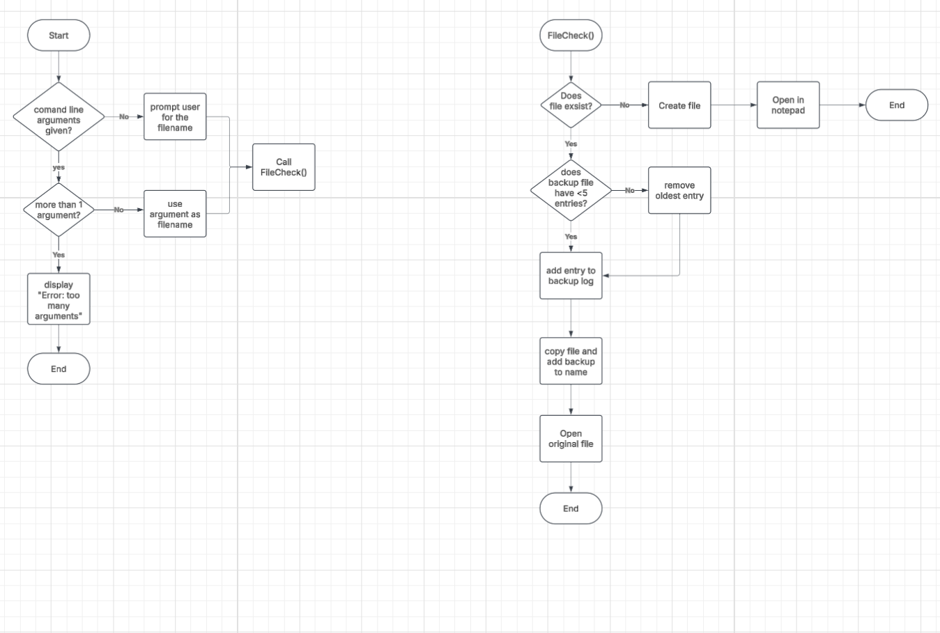

Testing:

Testing coverage explanation:

References:

